**Assignment-3**

InternshipJOVAC Hands on DevOps Using AWS Tools

**Name: Om Datt Tripathi University Roll no:2115000688**

**TASK 1**

1. Create an EC2 <FirstName_Assignment3> instance using Windows image t2 micro

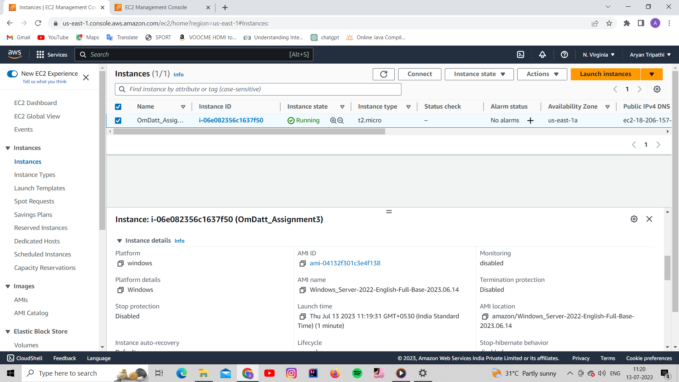

1. Create and Attach a Security Group with ports SSH, HTTP, HTTPS, All Traffic, RDP

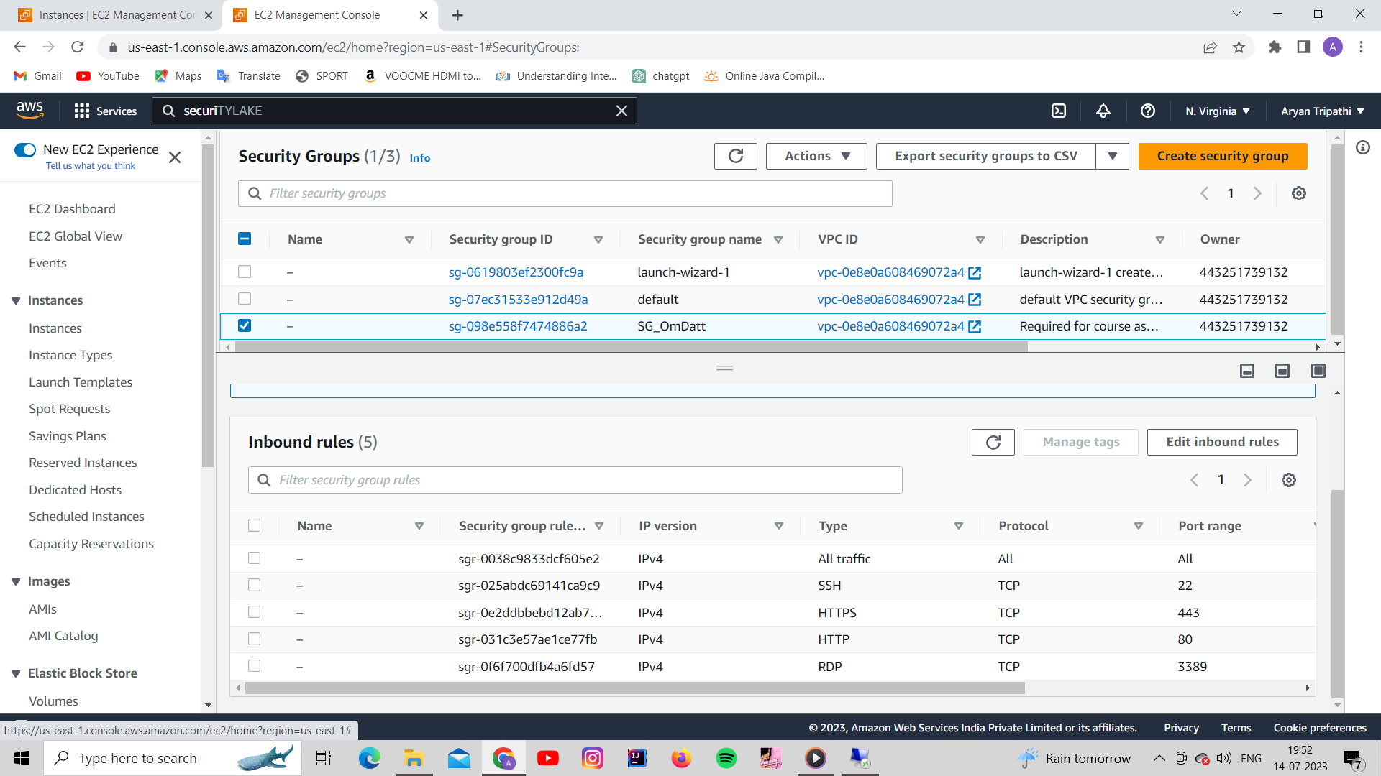

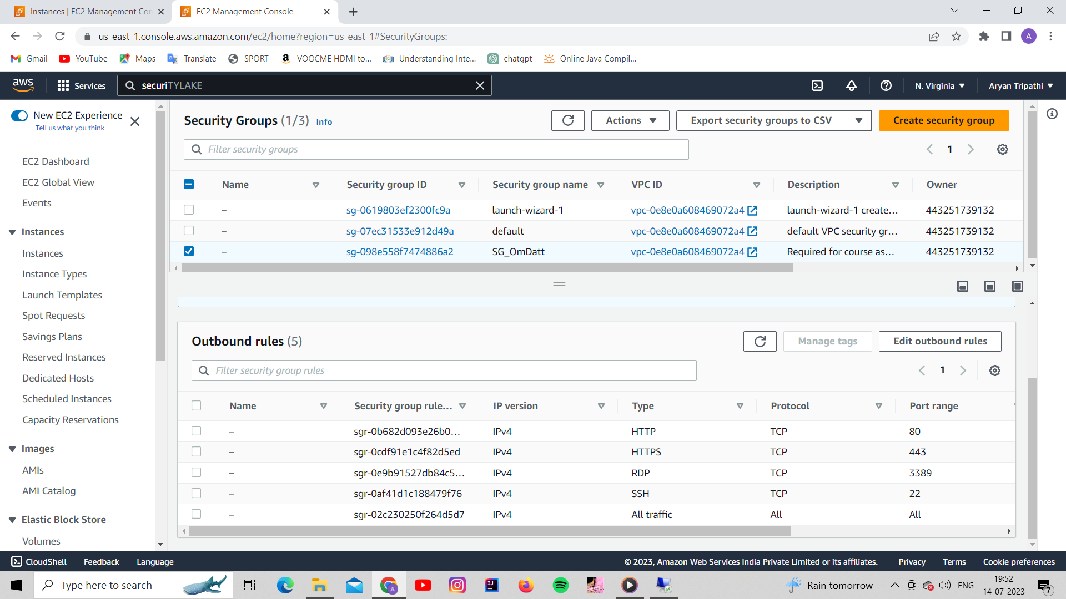

1. Connect your EC2 instance to RDP

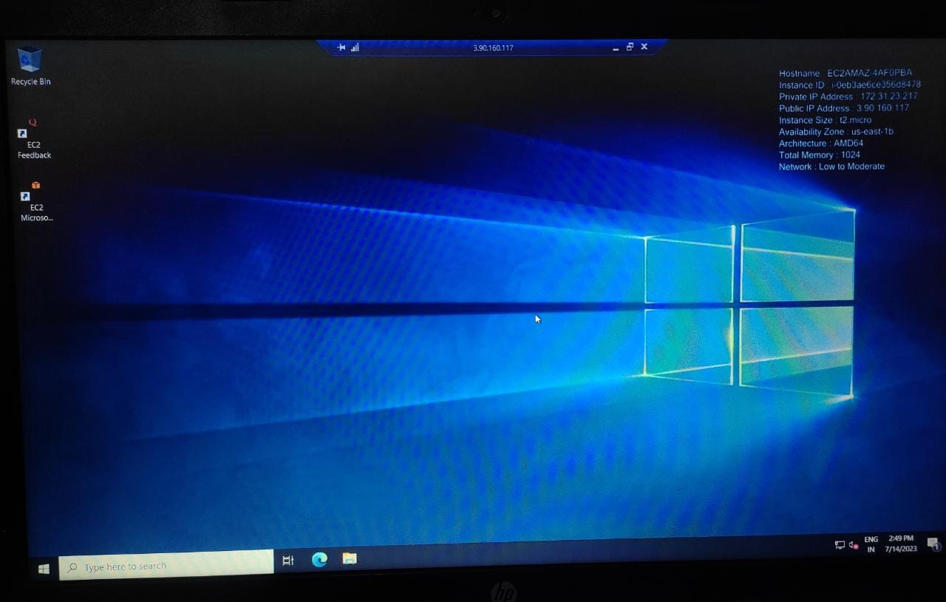

**TASK 2**

1. Create a new Dashboard <Firstname_Monitoring> in CloudWatch
2. Add metrics for EC2 instance (CPU utilisation, Networks)

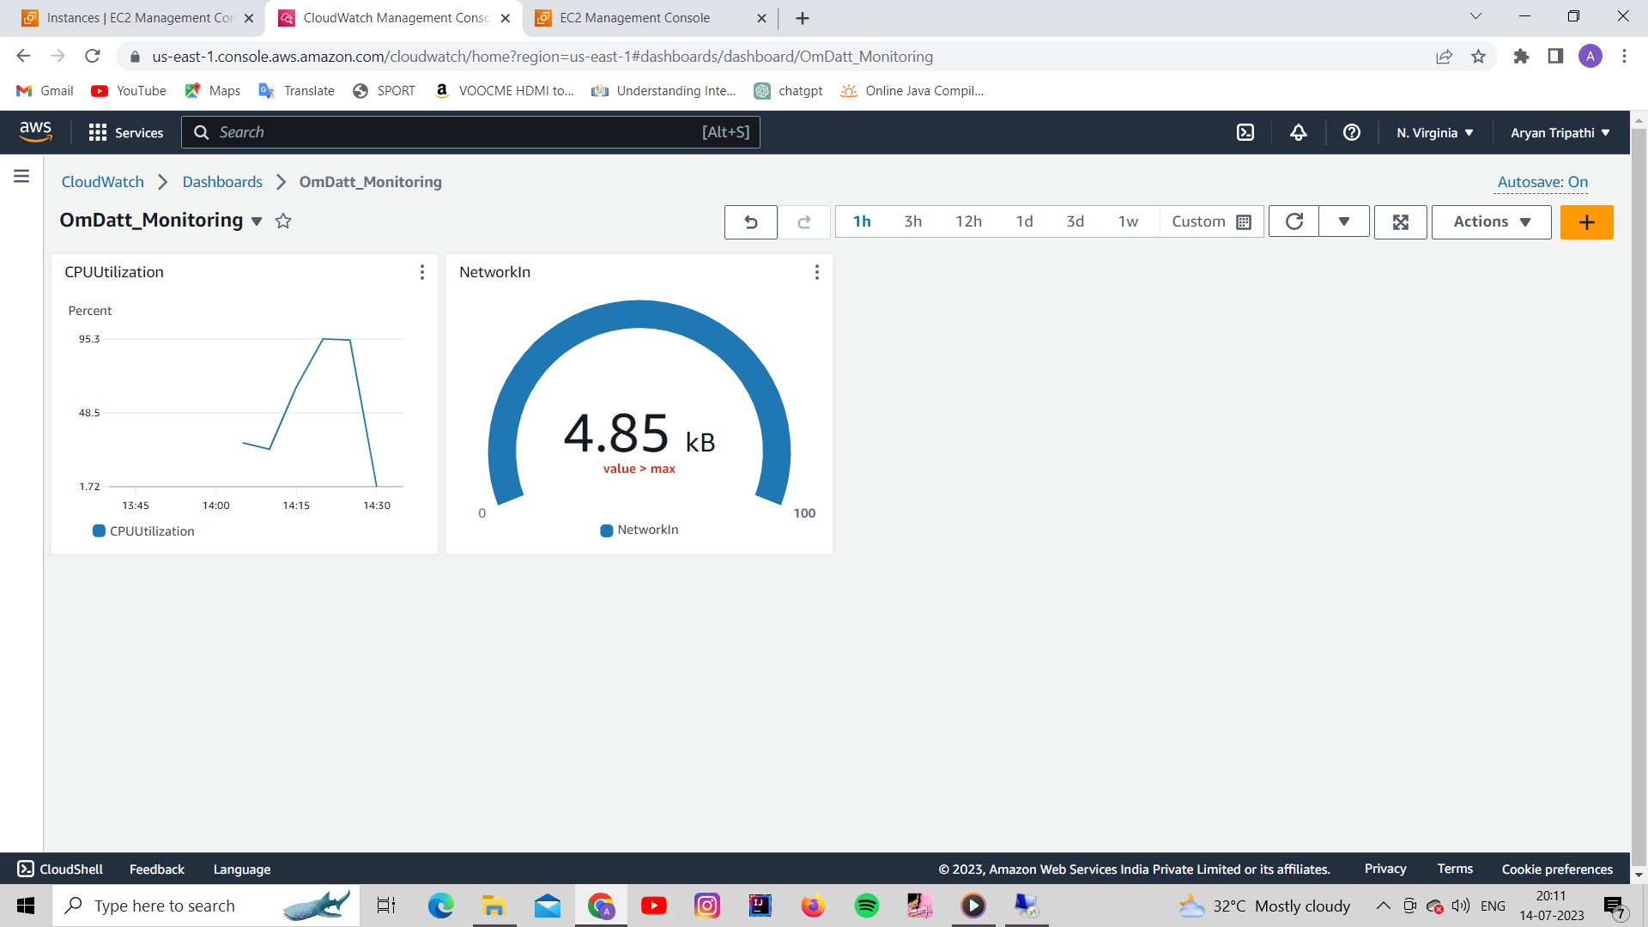

1. Save and Share dashboard publicly (take a screenshot)

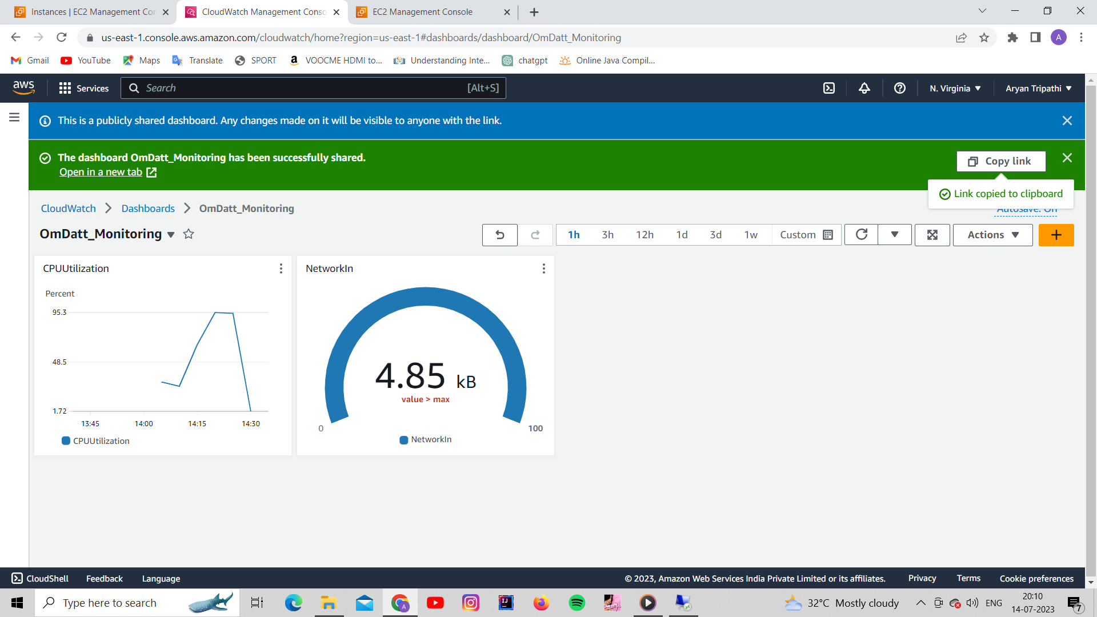

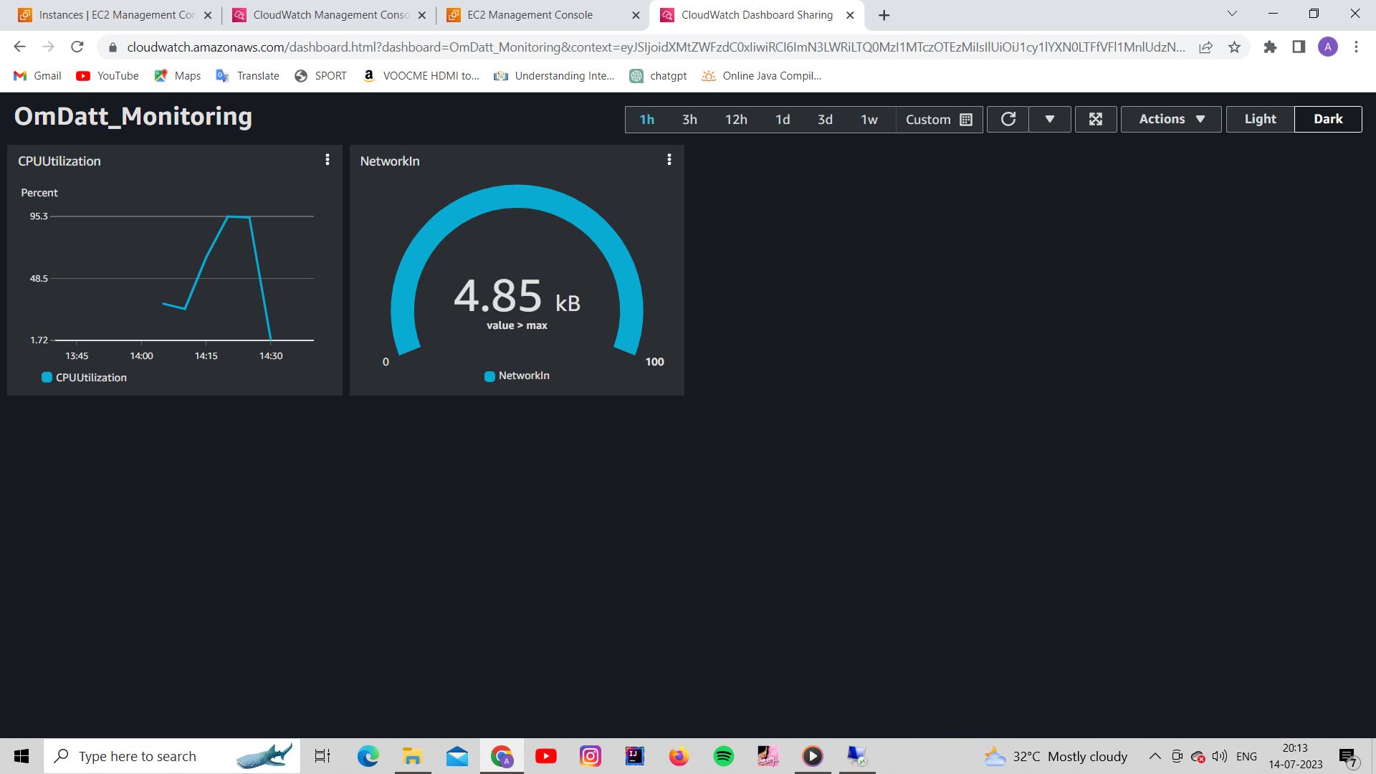

1. Create Alarms for CPU Utilisation <FirstName_CPUUtilisation)

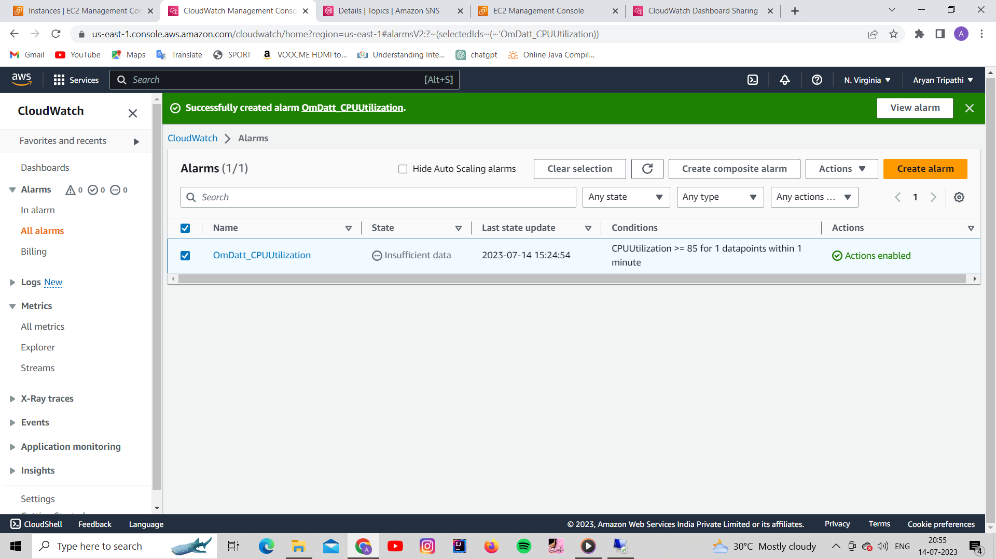

1. Set Threshold for 85%

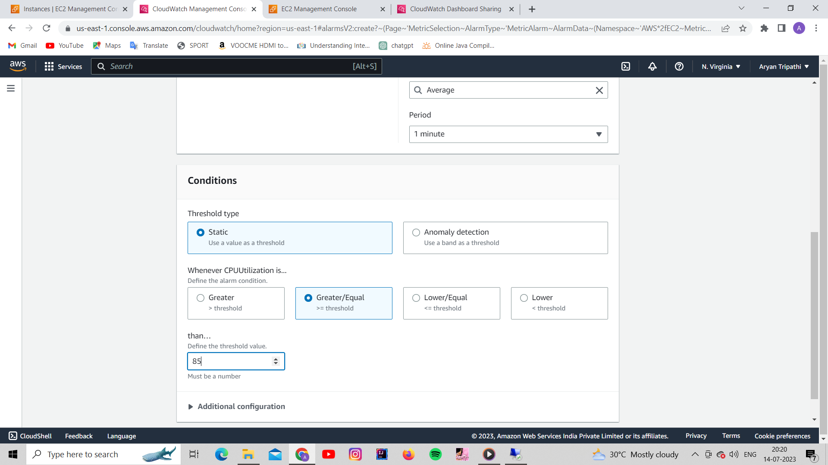

1. Create SNS topic and service and attach it to alarm

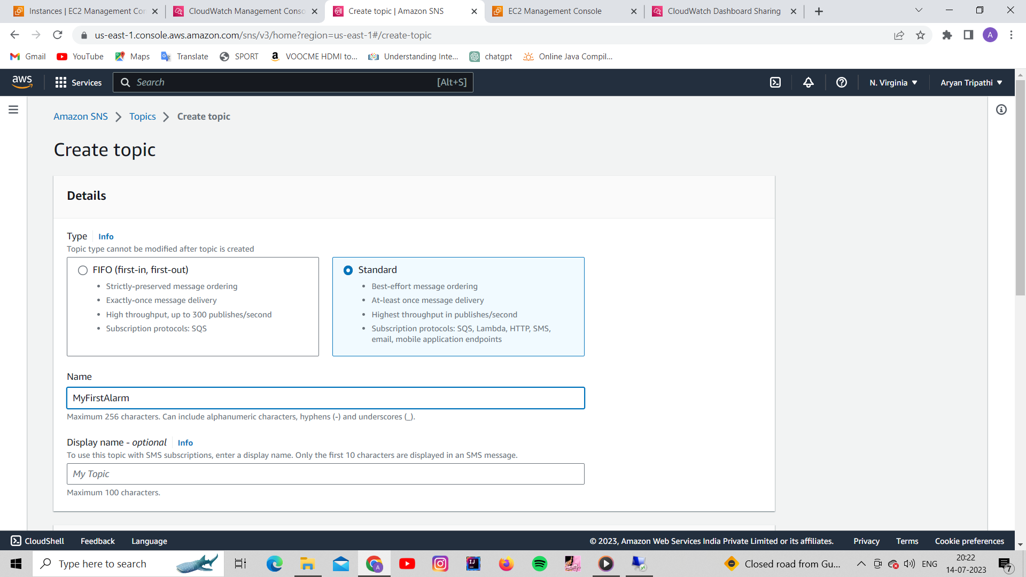

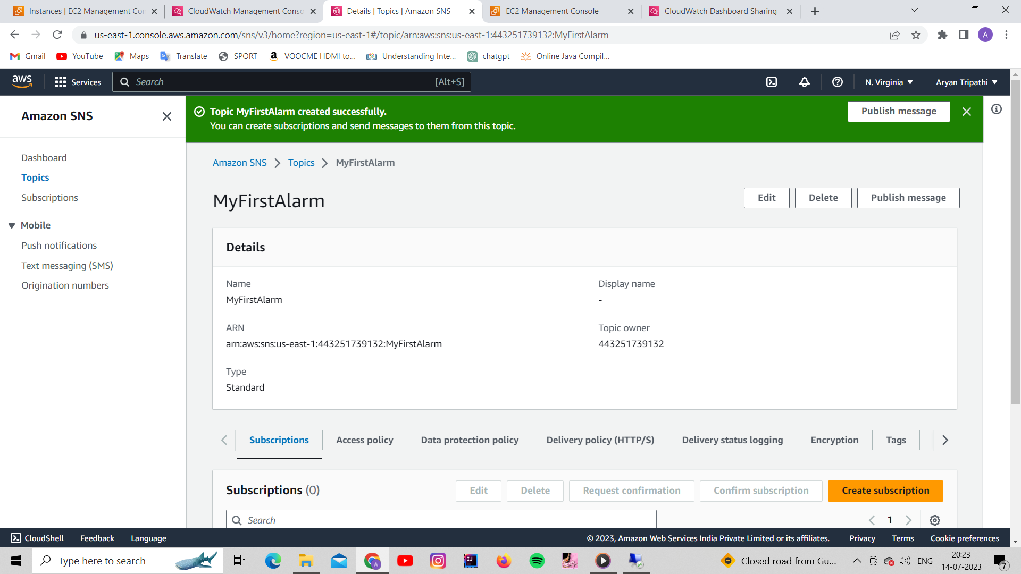

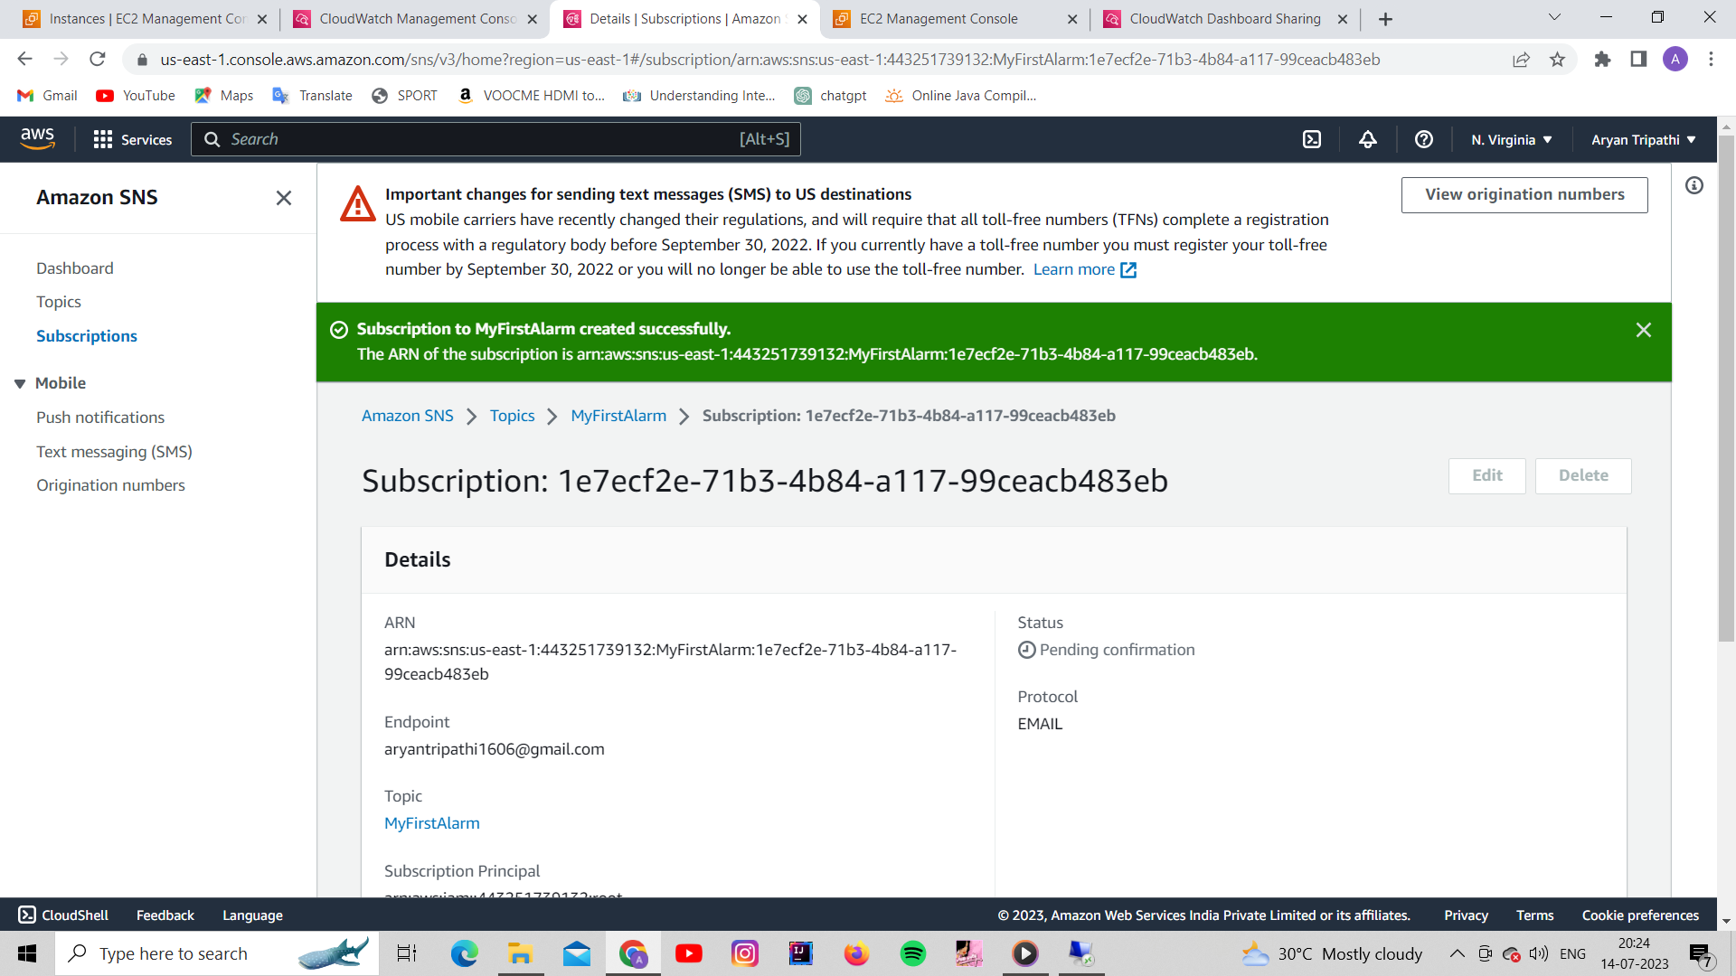

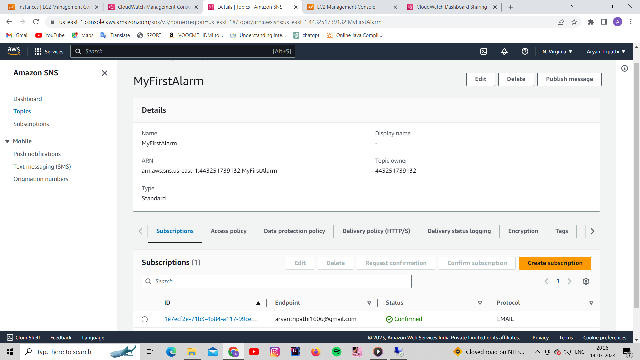

1. Select EC2 action to Stop the instance

**TASK 3**

1. Open RDP connect your EC2 instance



1. Create a VIRUS file with extension (.bat)   %0|%0

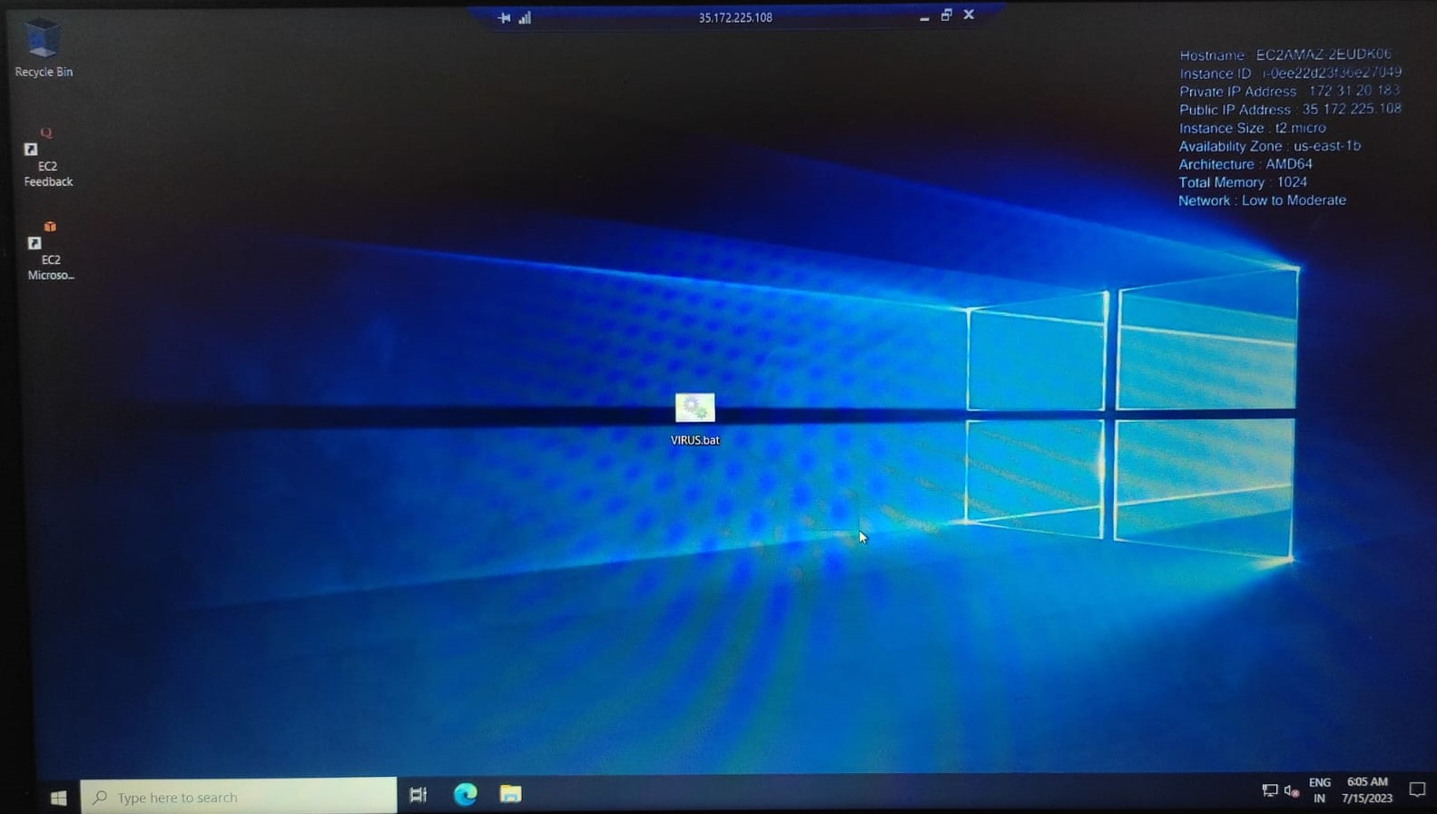

1. Run Virus file to max out system resources, wait for alarm to trigger.
2. Attach a screenshot of alarm triggered and email alert received and instance stopped

